MINISTRY OF NATIONAL EDUCATION
PETROLEUM – GAS UNIVERSITY OF PLOIEŞTI
FACULTY OF OIL AND GAS ENGINEERING
DOCTORAL FIELD: MINES, OIL AND GAS

TOPIC:

CONTRIBUTIONS TO THE STUDY OF PHENOMENA THAT ACCOMPANY FLUID MOVEMENT THROUGH PIPELINES

TABLE OF CONTENTS

pag
1. RESEARCH ON CRUDE OIL AND PETROLUEM PRODUCTS TRANSPORT THROUGH PIPELINES
A. Presentation of Romanian crude oils ……………………………………………….2
B. Properties of viscous crude oil and its rheological behavior ………….5
C. Rheological properties of viscous crude oil ……………………………………..7
D. Transport of viscous crude oil through pipelines ………………………………..8
E. Transport methods ................................................................................8

2. RESEARCH ON NATURAL GAS TRANSPORT THROUGH PIPELINES
A. Natural gas transport ………………………………………………….9
B. Study on the losses in natural gas transport …………………………………10

3. RESEARCH ON BIPHASIC TRANSPORT IN MIXED PIPELINES
A. Theoretical aspects involved in biphasic transport ………………………………15
B. Case studies
1. Oil transport pipeline from the plant to the store ……………………17
2. Mixture pipelines from the well to the separator plant ...………………….21

selective bibliography …………………………………………………22

ABSTRACT

The habilitation thesis is entitled Contributions to the study of phenomena that accompany fluid movement through pipelines and contains the research carried out in the three directions of applicability, namely: transport of crude oil and petroleum products through pipelines, transport of natural gas through pipelines and, respectively, biphasic transport through mixture pipelines..
For each of these research directions there will be presented below a summary of the research results.

1. RESEARCH ON CRUDE OIL AND PETROLUEM PRODUCTS TRANSPORT THROUGH PIPELINES

A. Presentation of Romanian crude oils
Romania, as an oil producing country, operates through OMV PETROM a series of oil and gas reservoirs. The maximum extraction capacity is 5,000,000 tons (gasoline, crude oil, condensate), which can be processed in the PETROBRAZI refinery with a current capacity of 4,300,000 tons, with possibilities to expand to 5,000,000 tons.
Following the classification according to the chemical composition, the hydrocarbon classes from the fraction distilling between 250 ° C and 300 ° C, the amount of paraffin in the oils and the asphalt content were determined (Table II.1).
Table II.1— Classification of crude oils according to their chemical composition, %
Classes of crude oils | Composition % of fraction 250-330 °C |  |  | Content % of:
Classes of crude oils | Paraffines | Naphthenes | Aromatics | Paraffin | Asphalt
paraffinic | 46-61 | 22-32 | 12-23 | 1,5-10 | 0-6
paraffinic-naphthenic | 42-45 | 38-39 | 16-20 | 1,0-6 | 0-6
naphthenic | 15-26 | 61-76 | 8-15 | traces | 0-6
paraffinic-naphthenic-aromatic | 27-35 | 36-47 | 26-33 | 0.5-1 | 0-10
aromatic | 0-8 | 57-78 | 20-25 | 0,0-0,5 | 0-20

Analyzing the density of crude oils (which in the case of crude oil of the same nature and source can also indicate its content in light fractions) and correlating two or more physical properties (based on the characterization factor, the viscosity index, the ratio between molecular mass and density etc.) a classification system based on hydrocarbon classes can be drawn, which takes into account the physical properties of crude oil and oil fractions (Table II.2).
Table II.2 Classification of crude oils according to the two key fractions
Class | Density of key fraction |  | Characteristics of crude oil according to the fraction |  | Symbol
Class | I | II | I | II | Symbol
1  2  3 | 0,825 | 0,875  0,876-0,943  0,944 | Paraffinic | Paraffinic Intermediate  Naphthenic | PP  PI  PN
4  5  6 | 0,826-0,860 | 0,875  0,876-0,943  0,944 | Intermediate | Paraffinic Intermediate  Naphthenic | IP  II  IN
7  8  9 | 0,861 | 0,875  0,876-0,943  0,944 | Naphthenic | Paraffinic Intermediate  Naphthenic | NP  NI  NN
One of the most complete classification methods is the “Carpathian” method.
Table II.3— Classes of crude oild in the “Carpathian” classification
Class | The names of crude oil classes | Essential chemical characteristics of the hydrocarbon classes
I | Paraffinic | $$C_{P}^{t}≥\text{72}$$
II | Paraffinic – naphthenic | $C_{P}^{t}≥\text{50};$ $C_{P}^{t}+C_{N}^{t}≥\text{90}$
II | Paraffinic – aromatic | $C_{P}^{t}≥\text{50};$ $C_{P}^{t}+C_{A}^{t}≥\text{90}$
IV | Paraffinic – naphthenic – aromatic | $C_{P}^{t}≥\text{50};$ $C_{N}^{t}>C_{A}^{t},$ $C_{A}^{t}>\text{10}$
V | Paraffinic – aromatic – naphthenic | $C_{P}^{t}≥\text{50};$ $C_{A}^{t}>C_{N}^{t},$$C_{N}^{t}>\text{10}$
VI | Naphthen – aromatic | $C_{P}^{t}<\text{50};$ $C_{N}^{t}>C_{A}^{t}$
VII | Aromatic – naphthenic | $C_{P}^{t}<\text{50};$ $C_{A}^{t}>C_{N}^{t}$

Table 4 shows the limits of the quality indexes.
Table II.4— Data that define crude oil classes
Quality charactestics | Limits for quality indexes
Non – waxy | c<2%
Waxy | c2%
Little resinous | r<2%
Resinous | 10%r<25%
Asphaltic | r25%
Non – sulphurous | s<0.5%
Sulphurous | s0.5%

The classification carried out by Creangă and called the “Carpathian” method was applied to the Romanian crude oil, at present being three classes of crude oil: asphaltic or non-paraffinic - type A; semi-paraffinic - type B; paraffinic - type C.
Analyzing the crude oil in Romania it is found that there is the possibility to classify these on the basis of the yield of light oil products obtained from the processing of each category:
- A1 - (24.3%) Heavy, without paraffin, < 60% “light oil products”
- A2 - (16.5%) Heavy, without paraffin, > 60% “light oil products”
- B - ( 8.4%) Semi-paraffinic crude oil
- C1 - (17.9%) Paraffinic crude oil, < 65% “light oil products”
- C2 - (30.9%) Paraffinic crude oil, > 65 % “light oil products”
Analyzing the quality of the crude oil and the pumping conditions through the CONPET pipelines (freezing temperature lower by 7 degrees than the soil temperature and viscosity of maximum 100 cSt) the following can be observed: type C crude oil has high freezing point and high quantity of light oil products and Type A crude oil has high viscosity and high quantity of heavy refining products.
Therefore, for the transport of crude oil, it is necessary to create mixtures by diluting it with products with low viscosity, which reduce the viscosity of type A crude oil, or by diluting it with products with low freezing point, which reduces the freezing point of type C crude oil.
If these diluents are not present in the oil fields, or in order not to affect the quality of the crude oil and therefore of the refining products (because the dilution of the crude oil is usually done by using non-compliant diesel or gasoline or other crude oil with different properties – mixtures of blend type) it is necessary to create some oil additives.
These additives are polymers or other chemical agents, which modify the precipitation of paraffin crystals from the solution, by one of the following mechanisms:
- the modifier exits the solution at a temperature slightly higher than the equilibrium temperature of the paraffin solution;
- the modifier exits the solution at an equilibrium temperature of the paraffin solution and co-crystallizes with the paraffin;
- the modifier exits the solution at a temperature slightly below the equilibrium temperature of the paraffin solution and is absorbed on the paraffin crystals.
The modifier present in the solution, acting through one of the above mechanisms, tends to maintain the paraffin molecules as separate entities, by reducing the cohesion forces between the crystals and the adhesion forces between the paraffin crystals and other surfaces.

B. Properties of viscous crude oil and its rheological behavior
The extraction of viscous crude oil started in 1967. Since the time these reservoirs were put into use, there have been used as extraction methods:
- emulsifying the crude oil in the well by introducing polymeric solutions,
- extraction of crude oil by CO₂ displacement,
- extraction by using types of water in oil emulsions (water in oil).
At present, due to the decrease of production, the extraction of oil from the well is done by using polymeric solutions. But the decrease of the production also led to the emergence of types of water in oil emulsions (oil in water), these emulsions being treated in the deposits near the reservoirs, the reservoir water being re-pumped to ensure the oil displacement. In 2018, a crude oil analysis was performed, the properties being:
Table II.8. Quality of crude oil in the area
Location sampling | Quality | Density 15ºC | Viscosity, cSt |  |  |  |  | Freezing temp. ºC
Location sampling | Quality | Density 15ºC | 10ºC | 20ºC | 30ºC | 40ºC | 50ºC | Freezing temp. ºC
Ileana | A3 | 0,9407 |  | 582,27 | 263,14 | 137,36 | 77,64 | -21
Poeni | A3 Sel. | 0,9252 |  | 260,64 | 119,63 | 74,65 | 45,30 | -40
Poeni | A3Nes+BRest | 0,8651 |  | 11,91 | 8,04 | 6,25 | 5,10 | -17
Roata | A3 Sel. | 0,9027 |  | 44,64 | 27,38 | 18,16 | 12,80 | -45

The variation of the kinematic viscosity with the temperature of the crude oil studied is presented in the figure below:
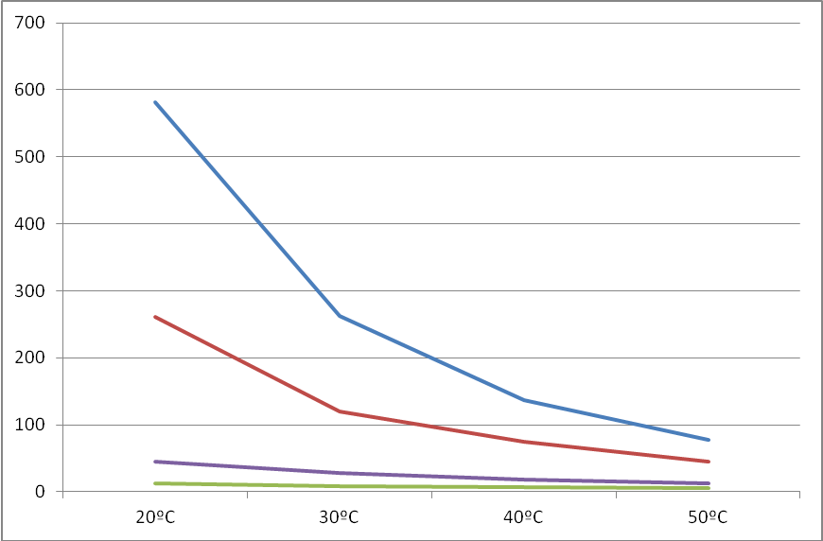
VISCOSITY, cSt
ILEANA A3
POIENI A3 SELEC
ROATA A3 SELEC
POIENI A3 NESELC+BREST
Figure II.2. Crude oil variation of kinematic viscosity with temperature
In order to observe how temperature influences crude oil (considering the constant along the length of the pipeline) on the energy consumption, a simulation was performed for a constant flow of 200 mc / day and oil pumping temperatures of 20ºC, 30ºC, 40ºC, 50ºC. As it can be seen, the crude oil in the studied deposit is asphaltic, with a low content of light oil products. It also has low freezing point and high density. At present, these crude oils are transported in batches (depending on the quantity extracted and the requirements of Brazi refinery). Given these conditions, energy consumption is very high.
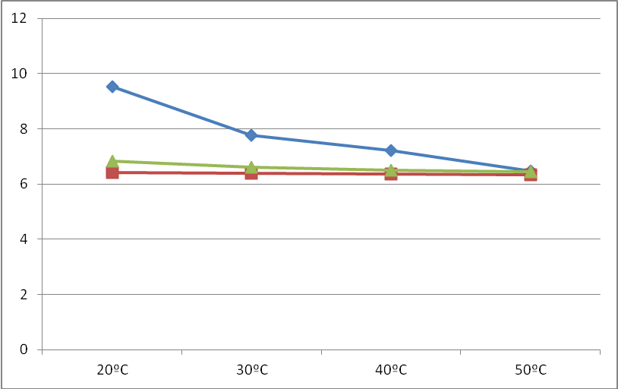
POIENI A3 NESELC+BREST
POIENI A3 SELC
Pumping pressure (10⁵ Pa)
Crude oil temperature
ROATA A3 SELC
Figure II.3. Pumping pressure of crude oils from the studied area
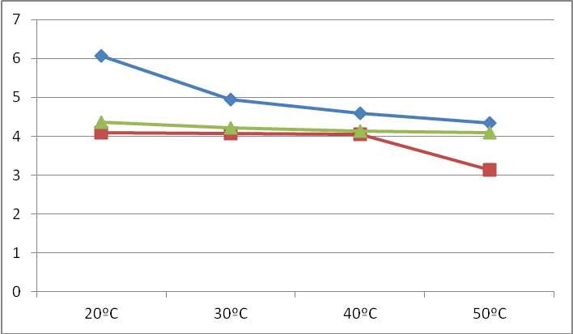
POIENI A3 NESELC+BREST
ROATA A3 SELC
POIENI A3 SELC
Crude oil temperature
Energy consumption (10⁴ W)
Figure II.4. Energy consumption of extracted crude oil

C. Rheological properties of viscous crude oil
The decline of medium and light oil reservoirs as well as the fall in the price of crude oil makes the exploitation of heavy (asphaltic) reservoirs not profitable by the classical methods (solvent extraction, polymer extraction, underground combustion). Also, the transport of heavy crude oil and bitumen through pipelines is difficult due to their high viscosity. Conventional hard oil deposits are estimated at 6 billion barrels, with Canada, Romania and Venezuela being the main states that operate and transport such crude oil through pipelines. The way of transport through pipelines of (bituminous and asphaltic) heavy oil can be realized as follows:
Transport heavy oil (asphaltic or bituminous)

By reducing viscosity
By reducing friction ob the pipeline walls
In situ processing (on site)

Dilution
Mixing
Using additives
Heating

Biphasic pumping in water ring
Emulsification

Reduction by freezing

Figure II.6. Way of processing crude oil to be transported through pipelines
D. Transport of viscous crude oil through pipelines
The temperature variation in the pipeline has a significant influence on the pumping of crude oil or petroleum products. Thus, the viscosity of the liquids varies in the opposite direction with the temperature and a sharp decrease of the latter produces a significant increase of the viscosity.
High transport difficulties may arise in this case of viscous crude oil. Also, some crude oil or petroleum products can reach the freezing point when the temperature in the pipeline drops. Finally, in paraffinic crude oil, in some cases, paraffin deposits appear on the wall of the pipeline, which reduces the inside diameter or leads to the clogging of the pipeline. From the transport point of view, the fact that a crude oil is freezable or is not appreciated only depending on the variation of the soil temperature in which the pipe is buried. For the transport through pipelines of high viscosity or freezing crude oil, several procedures have been proposed, some commonly used, others at an early stage of usage

E. Transport methods

1. Transport with diluents
Difficulties that arise when transporting viscous or freezing crude oil can be eliminated if it is pumped after mixing it with diluents. Gasoline, lamp oil, diesel, condensate, low viscosity crude oil etc. can be used as a diluent. The presence of diluents in crude oil improves its flow properties; also, diluents greatly reduce the concentration of paraffin in the mixture, part of it being dissolved in the light fractions of the diluents. It has also been found that, if the diluent is a slightly viscous crude oil, some of its components prevent the development of paraffin crystals.

2. Transport with additions
The process of transporting viscous or freezing crude oil with additions has begun to be used relatively recently. Such additions can be used in other cases as well. For example, in the turbulent transport of slightly viscous crude oil, an addition of polymers, with long and resistant molecules, reduces friction losses and therefore decreases the pressure drop. It should be noted that in laminar state these additions of polymers have no effect.

3. Hydro-transport
In order to reduce the pressure losses when transporting high viscosity crude oil through pipelines, transport with water, which is called hydro-transport, can also be used. In principle, this process can be carried out in several ways. The first of these consists in performing a concentric flow, the oil being isolated from the walls of the pipeline through a water ring.

4. Transport of heat-treated viscous or freezing crude oil
Experimentally, it has been found that by heating to a certain temperature, followed by cooling, the flow properties of viscous or freezing crude oil are temporarily improved. This process is called heat treatment and involves heating the crude oil up to a certain temperature and cooling it at a certain speed. Both the temperature and the cooling rate depend on the properties of the crude oil being transported, and must be established experimentally.

5. Heated transport
At present, the most widespread procedure in practice for the transport of viscous or freezing crude oil is its pumping after a preliminary heating. This process is usually called heated transport. In order to reduce the viscosity or to avoid reaching the freezing temperature in the pipeline, the crude oil is heated before entering the main pumping station, at a temperature not exceeding 343.16 K in order to avoid the increase in evaporation losses. The heating is carried out either in tanks fitted with coils that circulate a hot agent, usually steam, or by means of heat exchangers.
6. Defrosting pipes and combating paraffin deposits
If, however, freezing of the transported liquid occurs in a pipeline, defrosting can be done by pumping the same or less freezing liquid, previously heated to the maximum possible temperature. If the pipeline is completely blocked by freezing, it can be tried to dissolve the frozen part by pressure, with the help of a steam pump, gradually raising the pressure to the admitted limit which is the test pressure of the pipeline. In this way, only a short pipeline can be unclogged, and if the operation is to be applied to a longer pipeline it must be done on sections.

2. RESEARCH ON NATURAL GAS TRANSPORT THROUGH PIPELINES

A. Natural gas transport
Romania has a gas industry developed on the basis of its own resources, positioning itself as a production level in the first 12 gas industries of the world. But due to a long period of exploitation (over 90 years), it is felt, as in any extractive industry, the natural decline of flow and pressure, which is why it currently imports over 25% of the natural gas consumption requirement.
The natural gas industry, both extraction and transport, presents a significant variety of risks for workers in these fields (work incidents), for the population in the neighboring locations (major incidents) and for the environment.
The process of transporting gas through pipelines and distributing it to consumers is subject to specific regulations in all member countries of the European Union. The legislation in force aims to create distribution networks dimensioned according to the source-consumption balance, which will ensure the prospects for the development in time of consumption.
In Romania, the provisions of NTPEE-2008, “Normative for the design, execution and exploitation of natural gas supply systems” are applied. From the point of view of the technological elements within the production, transport, distribution and use of natural gas, the pipelines fall into the following pressure fields:
- high pressure> 6 bar (collecting pipelines, transport and technological installations related to the oil fields);
- average pressure, between 2 and 6 bar (gas supply systems);
- reduced pressure, between 0.05 and 2 bar (gas supply systems);
- low pressure <0.05 bar (gas supply systems).

B. Study on the losses in natural gas transport
Gas transport implies certain peculiarities compared to that of liquids, in particular related to the property of gas of being compressible, as a secondary reaction resulting in the release of heat. The distribution of gas through pipelines is achieved by means of gas pressure. Its processing in different technological processes in the chemical industry is generally done at high pressures compared to atmospheric pressure.
The important category of losses / additions is due to the variation of the state parameters at the moment of measurement: p${}_{c}$- in situ pressure; t${}_{c}$- temperature in situ; p${}_{s}$ - standard pressure; t${}_{s}$standard temperature. The volume of gas delivered to the consumer is measured by the turbine (meter) or diaphragm installed at the receiver. The gas consumption is made at the pressure p${}_{c}$ and temperature T${}_{c}$. These parameters may be different from their reference values p${}_{s}$, respectively T${}_{s}$. For our country, the reference state is characterized by the pressure of 760 mm mercury column (p${}_{s}$ - 1.01325 N / m²) and the temperature T${}_{s}$= 288.15 K (15ºC). If the friction in the turbine bearings, respectively the characteristics of the orifice does not change over time and the variation of pressure p${}_{c}$ and temperature T${}_{c}$ at the time of delivery is taken into account (which can be different from the standard values p${}_{s}$, respectively T${}_{s}$) there is a variation of the gas volume ${ΔV}_{c}$ with respect to the standard volume V${}_{s}$. The relative difference${{ΔV}_{c}}/{V_{s}}$ has the value:
$\frac{{ΔV}_{c}}{V_{s}}=\frac{p_{c}T_{c}−p_{s}T_{s}}{p_{s}T_{s}}$ (III.1)
The variation from one point to another of the delivery pressure p${}_{c}$ is much more significant and is much more difficult to track than the variation of temperature T${}_{c}$. Moreover, p${}_{c}$also differs depending on the altitude at which the consumer is located.
1. Analysis of the losses caused by gas humidity
Most often, gas contains water in the form of vapors, characterized by humidity u and expressed in kg/m³N. Humidity depends on the vapor pressure $p_{v}$of the water, the temperature, the gas composition, as well as the pressure p.
Saturation represents the state of the gaseous environment in which a new quantity cannot evaporate from a certain liquid (the characteristic size has reached its maximum value). At saturation, the water content is calculated with the formula:
$u=\frac{R_{g}}{R_{a}}\frac{p_{v}}{ρ_{\text{gV}}(p−p_{v})}$ (III.3)
$R_{a}$= 461,3929 m²/s²K; - water vapor constant, $R_{g}$= 188, 6431 m²/s²K – gas constant, $ρ_{\text{gV}}$- gas density in normal conditions, $ρ_{\text{gV}}$= 0,7194 kg/m³N, and $p_{v}$- vapor pressure of water at pressure p and temperature t.
If in the gas volume $V_{\text{ag}}$there is the volume of liquid water noted water, the fraction of water a is determined using the formula$a=\text{apa}⋅V_{\text{gN}}$. If gas volume metering is done by the orifice method, the correction coefficient c${}_{a}$ that has to be applied for obtaining the clean gas volume is calculated using the relation below:
$c_{a}=\frac{1}{1−\sqrt{a\frac{ρ_{a}}{ρ_{\text{gN}}}\frac{R_{a}}{R_{g}}}}$ (III.5)
The calculation of gas losses due to the discharge of water from a pipeline (separator) is performed differently for pipelines with pressure $p_{c}≤1,\text{85}×{\text{10}}^{5}$Pa (1.85 bar), respectively for those in which $p_{c}≥1,\text{85}×{\text{10}}^{5}$. In the first situation, if $p_{c}≤1,\text{85}×{\text{10}}^{5}$ and it is admitted that the pressure does not change significantly during the discharge, the volume of lost gas, expressed under normal conditions has the formula III.7 below:
$V_{1}=\frac{c_{d}f}{ρ_{\text{gN}}}\sqrt{\frac{2k}{k}\frac{p_{c^{2}}}{R_{g}T}\left[{\left(\frac{p_{a}}{p_{c}}\right)}^{2+k}−{\left(\frac{p_{a}}{p_{c}}\right)}^{(k+1)k}\right]}$ (III.7)
$c_{d}$- flow coefficient; $p_{a}$- atmospheric prressure; $p_{c}$- pipeline pressure (admitted as constant). The flow section f is determined by using the formula below:
$f=\frac{{πd}^{2}}{4}−0,\text{0272}L\frac{D^{2}\sqrt{\text{Di}}}{\sqrt{p_{c}}}$ (III.8)
d – the inner diameter of the regulator; L – the length of the separator; D – diameter; i – slope.
The time t in the equation is given by the following formula:
$t=0,{\text{9125}}/{\sqrt{\text{Di}}}+\text{60}$ (III.9)
The flow coefficient$c_{d}$ is determined with the relation below:
$c_{d}={\left(\sqrt{1+\frac{1}{d}λ+\sum_{i=1}^{n}{ζ_{i}}}\right)}^{−1}$ (III.10)
where l – the length of the nozzle through which the gas flows, d – the inner diameter of the nozzle, $\sum_{i=1}^{n}{ζ_{i}}$- the sum of all the hydraulic resistance coefficients (if local pressure losses occur along the nozzle length l), and$λ$- the longitudinal hydraulic resistance coefficient..
In the case of the separator with $p_{c}≥1,\text{85}$bar, the volume of lost gas is determined by the relation:
$V_{g}=\frac{c_{d}f}{ρ_{\text{gN}}}\sqrt{\frac{2k}{k+1}{\left(\frac{2}{k+1}\right)}^{2\left|k−1\right|}\frac{p^{2}}{R_{g}T}}$ (III.12)
where k – the gas adiabatic exponent ( example: k=1,32 for CH4)
The pipe has the inner diameter D and the length L, the inner pressure is $p_{c}$, and the hole has the inner diameter d and the flow coefficient$c_{d}$. The internal pressure in the pipeline can be compared to the pressure of 1.85 bar, in one of the relations $p_{c}≥1,\text{85}$bar, respectively $p_{c}≤1,\text{85}$bar. The volume of lost gas from the pipeles through the holes can be divided into volumes $V_{1}$ and $V_{2}$.. The first of these flows in the period of time $T_{N}=T_{a}+T_{b}$and is due to the fact that the pressure in the pipeline is higher than the atmospheric pressure $p_{a}$. The volume $V_{1}$ expressed under normal conditions has the formula:
$V_{1_{g}N}=\frac{{πD}^{3}}{4}L\frac{T_{N}}{{\text{Tp}}_{N}}\left(\frac{p_{c}}{Z_{t}}−\frac{p_{a}}{Z_{0}}\right)$ (III.13)
T – gas temperature in the pipeline; $p_{N}−$ reference pressure; $T_{N}$- reference temperature; $Z_{t}$ - the value of the deviation factor corresponding to the pressure$p_{c}$; $Z_{0}$ - the value of the deviation factor corresponding to the pressure$p_{a}$. If the hole remains open, the volume$V_{2}$ flows into the environment through circulation, during $T_{N}$. The calculation formula for this volume expressed under normal conditions is:
$V_{2_{g}N}=\frac{{πD}^{2}}{4}L\frac{T_{N}}{T}\frac{p_{a}}{Z_{N}}$ (III.14)
where$p_{a}$ - the atmospheric pressure at which the natural gas reaches when it starts to circulate;
In the case of filling a new or refilled pipeline, a volume of gas is lost depending on the conditions of the gas and the blown air in the pipeline. The filling pipe has the length L and the inner diameter D. In order to calculate the volume of the mixture natural gas - air, the diffusion coefficient must be determined $K=0,\text{2814}v_{m}D$where the inner diameter D is introduced in meters, as well as the diffusion number Peclet.
$\text{Pe}=v_{m}L/K$ (III.19)
where$v_{m}$- the average velocity of the gas that displacea the air in the pipeline.
The volume of mixing $V_{a}$ between natural gas and air can vary from 0 to 100%. The volume of mixing reported to the volume of the pipeline is calculated with the relation below:
$\frac{V_{a}}{V_{b}}=\frac{4z}{\sqrt{\text{Pe}}}$ (III.20)
unde z – is chosen according to the concentration values..
It is considered an orifice with section f and the flow coefficient$c_{d}$. The mass flow of gas M passed through the orifice is determined by the formula:
$M=c_{d}f\sqrt{\frac{2k}{k−1}p_{c}ρ_{c}\left[{\left(\frac{p_{e}}{p_{c}}\right)}^{2k}{\left(\frac{p_{e}}{p_{c}}\right)}^{(k+1)k}\right]}$ (III.21)
for $\frac{p_{e}}{p_{c}}≥{\left(\frac{2}{k+1}\right)}^{k/(k−1)}$. The mass gas flow is maximum and has the formula below:
$M_{\text{max}}=c_{d}f\sqrt{\frac{2k}{k−1}p_{c}ρ_{c}\left[{\left(\frac{2}{k−1}\right)}^{(k−1)/k}\right]}$ (III.22)
for: $0≤\frac{p_{e}}{p_{c}}≤{\left(\frac{2}{k+1}\right)}^{k/(k−1)}$where:$p_{c}$- the pressure inside the recipient (the pipeline); $p_{e}$- the pressure outside the recipient; $ρ_{c}$- density of gas corresponding to pressure $p_{c}$.
In the event that a fault is close to a channel with the length $l_{c}$and cross section$S_{c}$, a calculation can be made to determine the gas flow lost through the channel. Thus, the equivalent diameter of the channel is calculated and then the coefficient of longitudinal hydraulic resistance. The pressure drop between the ends of the channel with the length $l_{c}$ is, ${Δp}_{c}$and the average gas flow rate has the formula:
$v_{c}=\sqrt{\frac{2d_{c}{Δp}_{c}}{ρ_{c}l_{c}λ_{c}}}$ (III.24)
The flow through the channel under experimental conditions will be:
$Q_{c}=v_{c}S_{c}$ (III.25)
and can be expressed under normal conditions using the relation$Q_{c}p_{c}=Q_{v}p_{v}$
The selection of metering methods and equipment, for some demands given at the most convenient cost, is a complex problem that takes into account more than several criteria.
The measurement of gas flows can also be carried out using meters which can be of several types: a) with turbine; b) with pistons; c) with ultrasound; d) mass; e) with membrane.
a) The turbine meter consists of a segment of cylindrical pipeline in which the section rotates theoretically without rubbing the propeller (turbine). The rotational speed of the propeller is proportional to the speed (flow) of the fluid flowing through the pipe segment.
Turbine meters, also called speed meters, are convenient in operation, allowing for various assemblies, including the remote index display. Mounting can be done in any position, even vertically, but it is necessary to respect the flow direction indicated by the manufacturer. The flow of gas must be uniform, being contraindicated the upstream installation of the meter of some devices that could lead to the interruption of the gas flow (filters, regulators). It is not necessary to provide some rectilinear portions before and after the meter and this is an important aspect to be taken into consideration. In case of mounting the meter by means of reductions, the conicity must not be higher than 30 °.
b) The principle of operation of the piston meter is based on the filling and emptying of two semicircular spaces, by reversing the two pistons in the form of eight in two directions. The gas circulation rotates the two pistons. At each rotation, a precise volume of gas is measured. This movement is mechanically relayed to a totalizer that measures the number of rounds and displays directly (in m³) the volume passed through the pressure chamber.
c) Ultrasonic (ultrasonic) meters, based on one or more ultrasonic signals which, by simple or successive reflections, measure the average speed of the fluid passing through the meter section. The operating principle is the emitting/receiving of signals from the transducers, signals that are disturbed by the gas flow rate. The transducers emit signals in the direction of gas flow when the signal speed is accelerated and in the opposite direction of the gas flow, when the signal speed is slowed down by the gas flow rate. The latest generation of ultrasonic meters can measure bidirectional flows and can detect distorted profiles. They do not introduce additional pressure drops other than equivalent pressure drops proportional to the length. They have no moving parts and require minimum upstream pipeline lengths. They have a wide range of measurement and their calibration is simple and easy. These flow meters are used especially for transactional measurements and for underground gas storage.
d) Mass meters are also used as direct measurement method. For these, temperature and pressure corrections are not required. The operating principle is based on the flow conversion of the fluid passing through the meter rotation moment.
With the help of a synchronous electric engine, a turbine is driven, through which the fluid passes, this inducing a moment of rotation. A measuring turbine absorbs the moment of rotation induced by a torque proportional to the mass flow. This couple is transmitted to a gyroscopic integrator. By means of a gear drive, the flow in kg of fluid passed through the meter is transmitted to an indicator.
e) Membrane meters are of volumetric type, designed to measure the domestic consumption of natural gas. The most used are of the dry type with membrane, in three sizes, for flow rates of 3, 6 and 20 m3 / h and are provided with a mechanism for recording consumption.
2. Error analysis in measuring gas flow
In order to observe the differences recorded on two types of flow meters, the measurements over a period of one month were taken into account by a gas supplier. Two modes of registration were used, one accepted by the gas transport company and the other by the supplier. Measurement with SYSCOM 18 differential counter, having 1% accuracy class and having the following characteristics: Hl_{maxim}=1500 mm H₂O și p_{maxim} = 4 bar. The measurement with the rotary meter has the 0.2% accuracy class at temperatures of 20 ° C. The two systems are connected in parallel being used to determine the gas flow taken over by TRANSGAZ from OMV PETROM. As seen, the turbine meters are better, the difference between the two being 12062 thousand m³ per month. The error between the two systems is 2.03%, so OMV would bear the losses if they used the differential system. It is worth mentioning that the differential system is useful for coarse measurement and not for gas delivery measurement.
Natural gas transmission systems are provided with the necessary equipment, equipment and personnel to prevent and eliminate possible fires caused by natural causes (earthquakes, landslides) or human actions. Compared to the measures adopted by design for the reduction of the technical risk, during the exploitation phase, the measures of prevention, control and mitigation of the impact in case of damage must be respected.

3. RESEARCH ON BIPHASIC TRANSPORT IN MIXED PIPELINES

A. Theoretical aspects involved in biphasic transport
1. Thermodynamics of two-phase systems
According to the terminology used in thermodynamics, the two-phase “liquid-vapor” mixture is called wet vapor, and saturated vapors without liquid are referred to as dry saturated vapors. So, wet vapors are a mixture of saturated liquid and dry saturated vapors. Vapors whose temperature is higher than saturation, at a given pressure, are called superheated vapors.
To unambiguously define the state of a two-phase system, it is essential to know the relationship between the mass of the liquid and that of its vapors. The title δ of a two-phase mixture is named the ratio of the mass of dry saturated vapors$G_{\text{vap}}$, contained in the mixture to the total mass G of the mixture.

$δ=\frac{G_{\text{vap}}}{G}$$=\frac{G_{\text{vap}}}{G_{\text{lich}}+G_{\text{vap}}}$, (IV.1)

2. Calculation of pressure gradients in two-phase transport
In the field literature there are several methods of calculation for pressure gradients ${Δp}/l$ as well as of the other elements characteristic of the tow-phase phasic movement. The following are presented: Lockhart-Martinelli method, Brill-Beggs method, P.G.U. method, proposed by the Hydraulics team, from the FET Department of the Petroleum-Gas University of Ploieşti and the method of assimilating the two-phase fluid with a single-phase one.
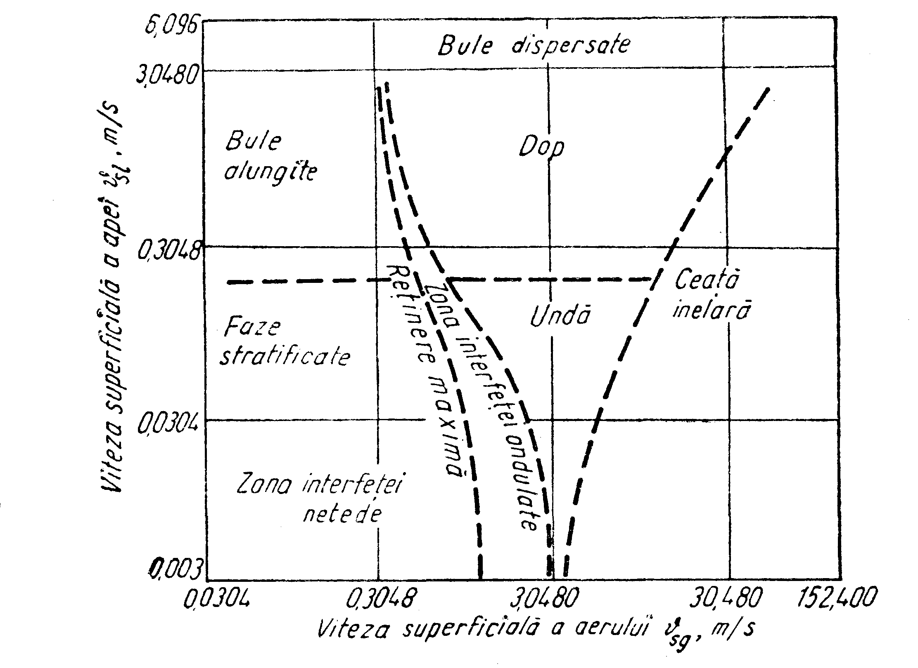
Fig. IV.3. Types of flow for the air-water system
3. Special methods of calculating the pressure drop in two-phase flow
1. Friedel Method. Metoda de corelare a lui Fridel’s (1979) correlation uses a two-phase multiplier: ${\text{Δp}}_{\text{frict}}={\text{Δp}}_{L}Φ_{\text{fr}}^{2}$ where Δp_{L} is calculated for the liquid phase as follows:
${\text{Δp}}_{L}=4f_{L}\left({\text{L/d}}_{i}\right){\overset{˙}{m}}_{\text{total}}^{2}\left({\text{1/2ρ}}_{L}\right)$ (IV.82)
This method is usually recommended when the ratio (µL/µG) is below 1000.
2. Chisholm Method. Chisholm (1973) proposed an empirical method applicable to a wide range of operating conditions. The frictional pressure gradient is:
${\left(\frac{\text{dp}}{\text{dz}}\right)}_{\text{frict}}={\left(\frac{\text{dp}}{\text{dz}}\right)}_{L}Φ_{\text{Ch}}^{2}$ (IV.90)
The frictional pressure gradient for the liquid and vapor phases is:
${\left(\frac{\text{dp}}{\text{dz}}\right)}_{L}=f_{L}\frac{2{\overset{˙}{m}}_{\text{total}}^{2}}{d_{i}ρ_{L}}$${\left(\frac{\text{dp}}{\text{dz}}\right)}_{G}=f_{G}\frac{2{\overset{˙}{m}}_{\text{total}}^{2}}{d_{i}ρ_{G}}$ (IV.92)
3. Bankoff Method. Bankoff’s method (1960) is an extension of the homogeneous model. The friction pressure gradient for two phases is given by the relation:
${\left(\frac{\text{dp}}{\text{dz}}\right)}_{\text{frict}}={\left(\frac{\text{dp}}{\text{dz}}\right)}_{L}Φ_{\text{Bf}}^{\text{7/4}}$ (IV.96)
4. Chawla Method. Chawla (1967) suggested the following method based on the vapor pressure gradient:
${\left(\frac{\text{dp}}{\text{dz}}\right)}_{\text{frict}}={\left(\frac{\text{dp}}{\text{dz}}\right)}_{G}Φ_{\text{Chawla}}$ (IV.99)

B. Case studies
1. Oil transport pipeline from the plant to the store
1. Input data. The separate crude oil in the separator plant must be pumped to the store through a new pipeline. In order to define the requirements of the new equipment (separators, pumps etc.) that will be installed, it is necessary to perform the hydraulic simulation for this pipeline.
The input data for the simulation are the following: Pumped flow rate: 20 ÷ 600 m³/day, Pump temperature: 40 ⁰C, Clean oil viscosity/density, Reservoir water density: 1055 kg/m³.
There will be simulated 3 scenarios: 1: 10 % reservoir water; 2: 20 % 3: 40 %. These options will be simulated for 3 pipeline diameters, the length being 11176 m: Ø1 = 102,26 mm; Ø2 = 146,33 mm; Ø3 = 202,72 mm, The pressure of Poiana Lacului deposit: 2 bar, The average environmental temperature: 7⁰C. Pipeline insulation thickness: 3 mm
2. Output data. The simulations were performed using numerical modeling software developed by IHS Energy Group.
The calculation used Beggs and Brill method.
Scenario 1: a. Pipeline diameter: ø1 = 102,26 mm;
Content of reservoir water: 10%
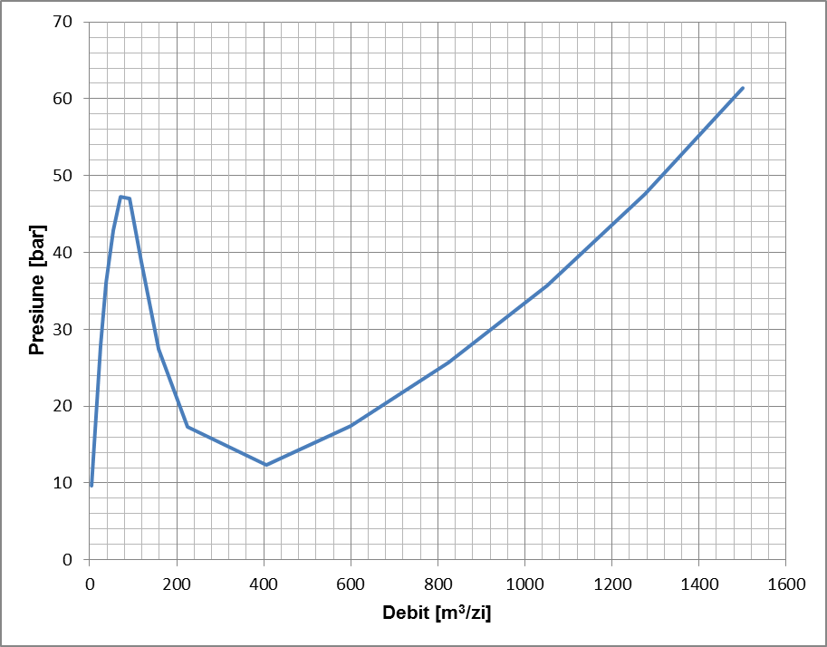
Fig. IV.9. Pressure and flow variation in the store
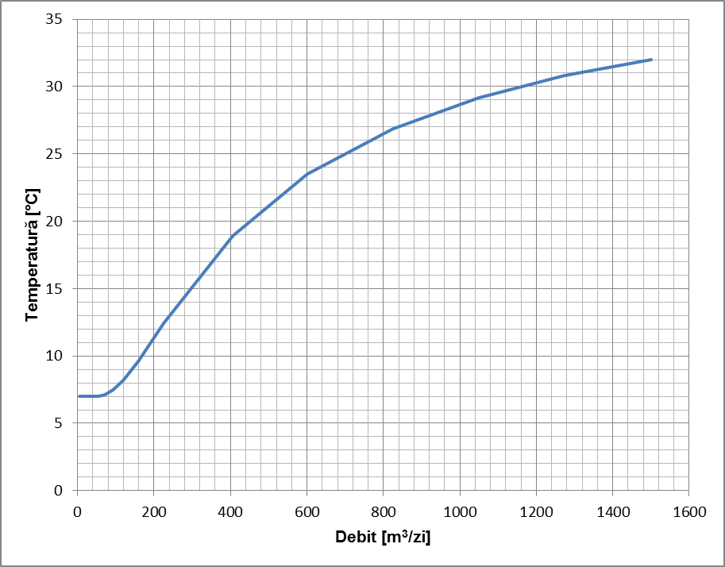
Fig. IV.10. Temperature and flow variation in the store
b. Simulation of pressure variation in the store for the three selected diameters
- Pipeline diameter: ø1 = 102,26 mm; ø2 = 146,33 mm; ø3 = 202,72 mm.
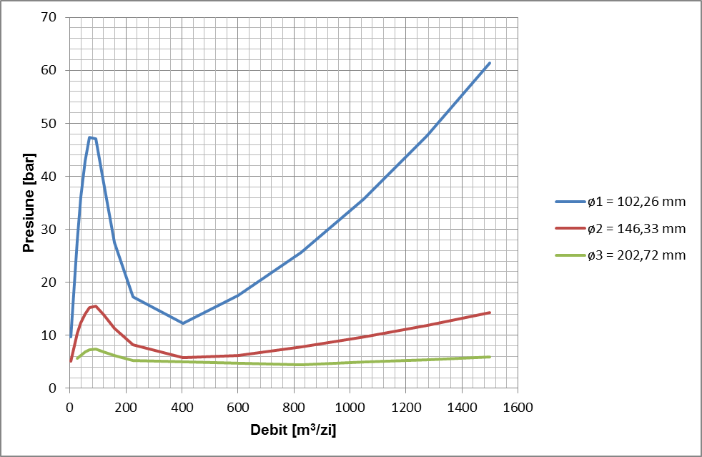
Fig. IV.27. Pressure variation in the store, at a flow I=10%
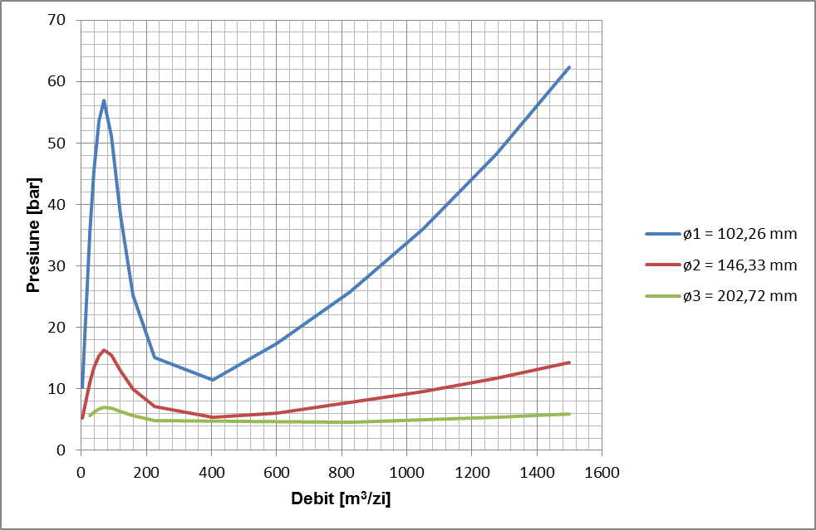
Fig. IV.28. Pressure variation in the store, at a flow I=20%
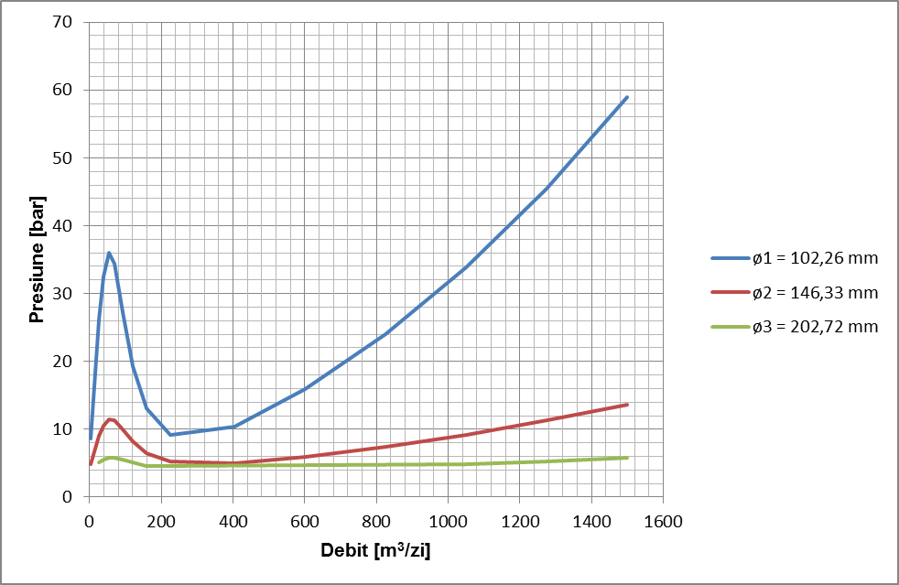
Fig. IV.29. Pressure variation in the store, at a flow I=40%
c. Simulation of temperature variation in the store for the three selected diameters
- Pipeline diameter: ø₁ = 102,26 mm; ø₂ = 146,33 mm; ø₃ = 202,72 mm,
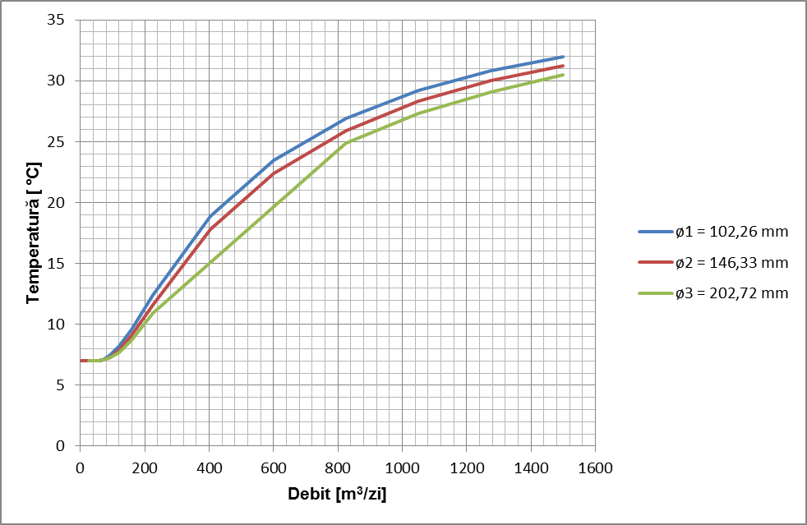
Fig. IV.30. Temperature variation in the store, at a flow I=10%
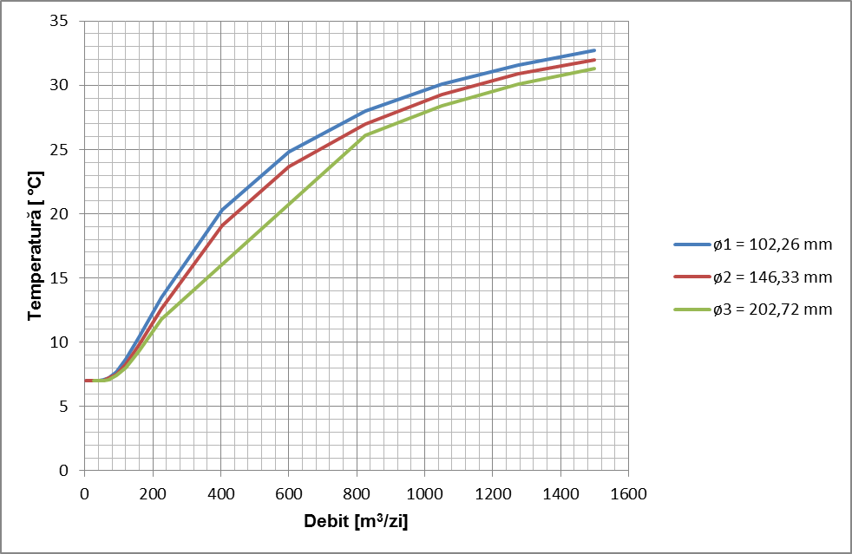
Fig. IV.31. Temperature variation in the store, at a flow I=20%
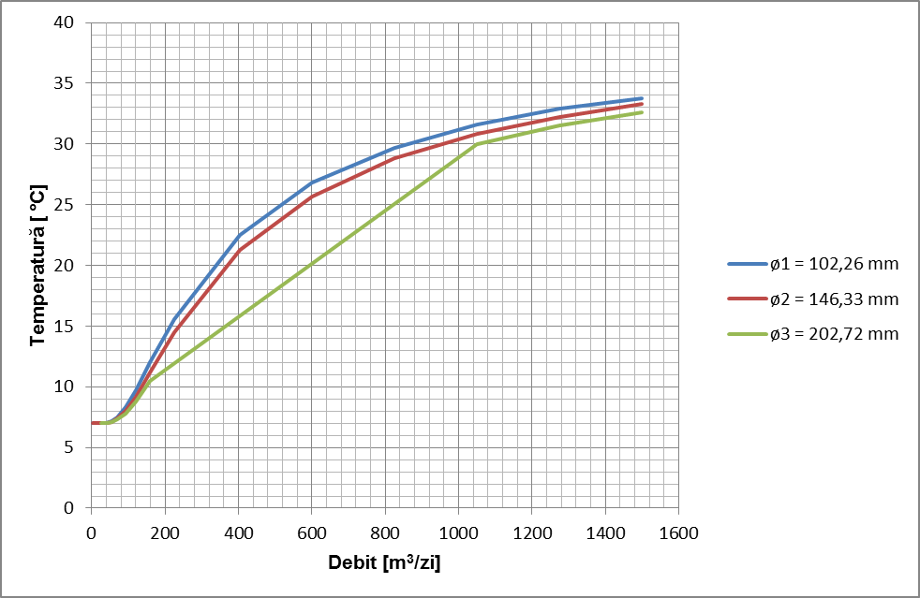
Fig. IV.32. Temperature variation in the store, at a flow I=40%
d. Simulation of pressure variation in the store, depending on impurities
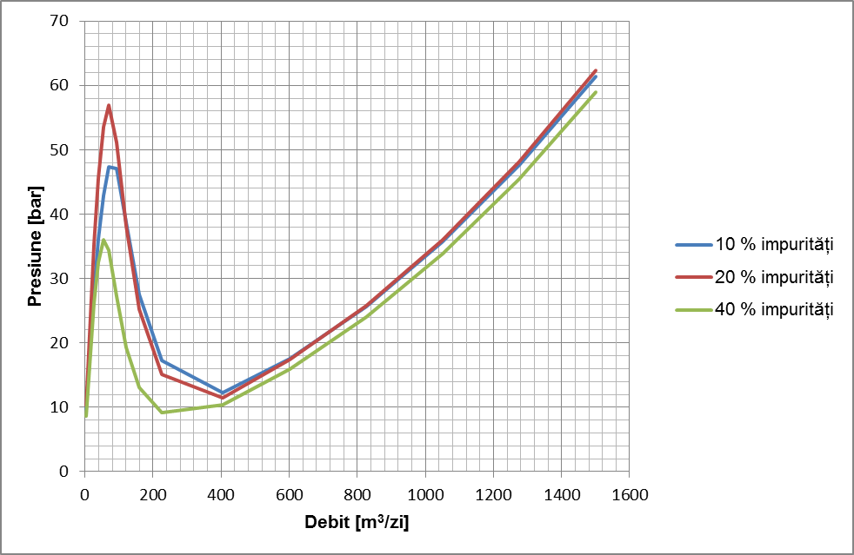
Fig. IV.33. Pressure variation in the deposit at a flow ø = 102,26 mm;
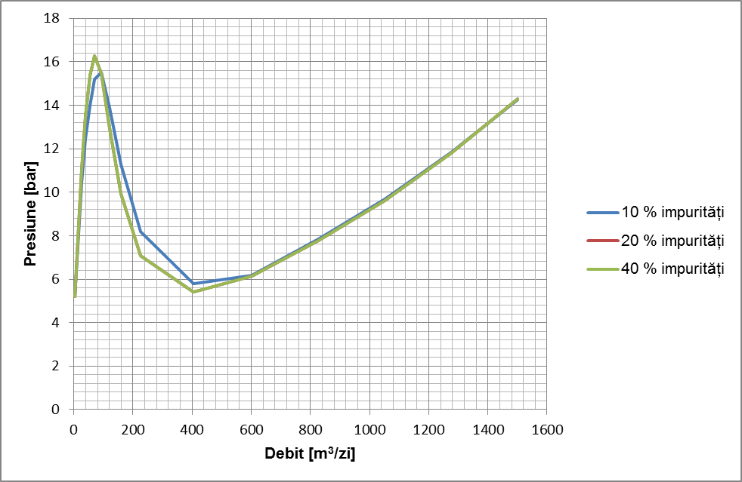
Fig. IV.34. Pressure variation in the deposit at a flow ø = 146,33 mm
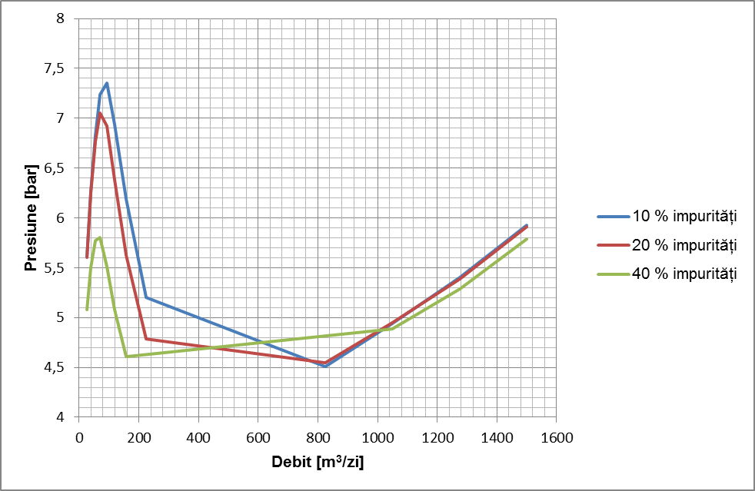
Fig. IV.35. Pressure variation in the deposit at a flow ø = 202,72 mm

2. MIXTURE PIPELINE FROM THE WELL TO THE SEPARATOR PLANT

1. Input data. The mixture extracted from the well should be pumped to the separator plant through a pipeline with an inside diameter of 102.26 mm, with a roughness of 0.01651 mm. The pipeline has a length of 15,000 m and it is buried. 3 (three) scenarios will be simulated: for 3 gas-liquid ratios, and 2 percent impurities. Scenario 1: RGL = 136 mcG/mcl; 2: RGL = 250 mcG/mcl; 3: RGL = 350 mcG/mcl; Impurities a: I1 = 15% reservoir water, I2 = 40% reservoir water. Pressure at the plant: 2 bar. Average environmental temperature: 7⁰C. Insulation thickness 3 mm.
Simulations of the dependence of the pumping pressure and the oil temperature, depending on the flow rate, will be performed for the 3 ratios and the 3 impurity contents. The simulations were performed using numerical modeling software developed by IHS Energy Group. The calculation used the Beggs and Brill method.
2. Results of the simulations
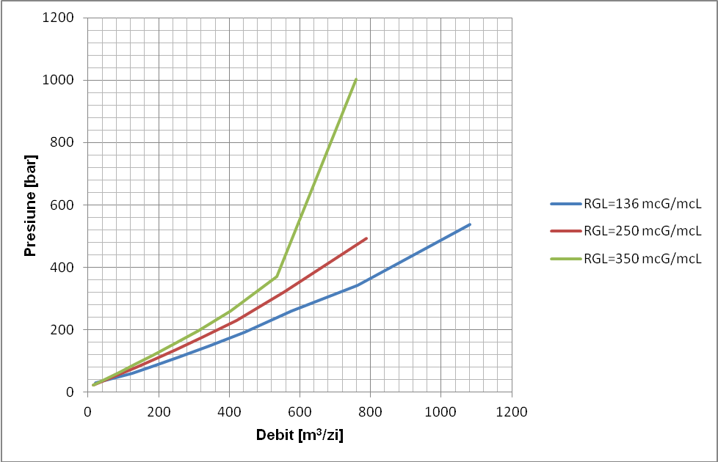
Fig. IV.39. Pressure variation for the 3 gas – liquid ratios with impurities I1=15%
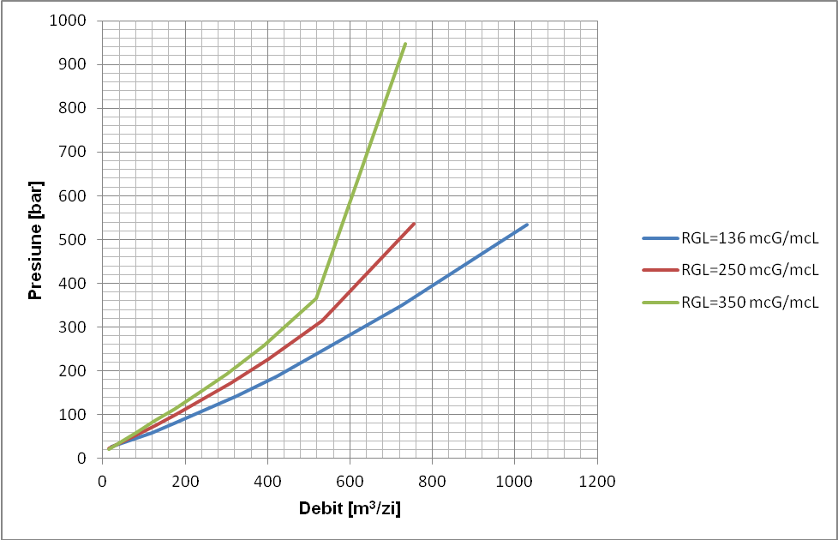
Fig. IV.41. Pressure variation for the 3 gas – liquid ratios with impurities I2=40%

selective bibliography

- Albulescu, M., Mecanica fluidelor, Editura Universitatii Petrol-Gaze Ploieşti, 2004
- Abarasi Hart, A review of technologies for transporting heavy crude oil and bitumen via pipelines, J Petrol Explor Prod Technol, DOI 10.1007/s13202-013-0086-6,
- Koncsag Cl.I., Fizico-chimia petrolului, Editura Ovidius University Press, Constanța, 2003,
- OMV-PETROM S.A. Raport privind extracția țițeiurilor românești, Raport intern, 2014,
- COPET S.A. Raport privind calitatea țițeiurilor românești, Raport intern, 2014.
- Hasan SW, Ghannam MT, Esmail N Heavy crude oil viscosity reduction and rheology for pipeline transportation., 2010, Fuel 89:1095–1100,
- Lin CY, Chen LW , Emulsification characteristics of three and two phase emulsions prepared by ultrasonic emulsification method. 2006, J Fuel Process Tech 87:309–317,
- A.N.R.M. Concesiunile de petrol și gaze din Romania, Raport 2014, www.narm.ro,
- ASTM D86 - 11b Standard Test Method for Distillation of Petroleum Products at Atmospheric Pressure,
- ASTM D97 - 11 Standard Test Method for Pour Point of Petroleum Products,
- ASTM D1298 - 99(2005) Standard Test Method for Density, Relative Density (Specific Gravity), or API Gravity of Crude Petroleum and Liquid Petroleum Products by Hydrometer Method,
- ASTM D1665 - 98(2009) Standard Test Method for Engler Specific Viscosity of Tar Products,
- CONPET S.A.PLOIEŞTI-Analiza ţiţeiurilor transportate prin sistemul naţional de transport, studiu intern, Ploieşti, 2014,
- http://www.tribology-abc.com , accesat 8.6.2014,
- Albulescu M., Trifan C., D. Chisăliţă. Asupra analizei uzurii sistemelor de distribuţie gaze naturale. Buletin U.P.G.Ploieşti, vol.LVI, Seria Tehnică nr. 3/2004.
- Albulescu Mihai, Doru Stoianovici, Robertino Cătălin Diaconu, Tiberiu Florin Trifan; The Numerical Simulation of Main Gas Pipelines Exploitation when the Pressure Varies, Petroleum-Gas University of Ploieşti Bulletin, Vol.LXIX, No.1/2017,
- Diaconu Robertino Cătălin, Mihai Albulescu, Doru Stoianovici, Tiberiu Florin Trifan; About the Exploitation of Gas Pipelines; Petroleum-Gas University of Ploieşti Bulletin, Vol.LXIX, No.1/2017,
- Oroveanu, T. David, V., Stan, Al., Trifan, C. Colectarea, transportul, depozitarea şi distribuţia produselor petroliere şi gazelor, E. D. P., Bucureşti, 1985
- Simescu, N.,Trifan,C., Albulescu, M., Chisăliţă, D. Activitatea gazieră din România în tranziţie la o piaţă liberă, funcţională şi integrabilă în Uniunea Europeană Editura UPG Ploieşti, 2008
- Trifan, C. Albulescu, M., Hidraulica, transportul şi depozitarea produselor petroliere şi gazelor, Editura Tehnică, Bucureşti, 1999
- Trifan, C., Albulescu, M., Neacşu, S. Elemente de mecanica fluidelor şi termodinamică tehnică. Editura U.P.G., 2005, Ploieşti
- Trifan, C. Distribuţia gazelor naturale prin reţele de conducte. Editura U.P.G. Ploieşti. 2005.
- Albulescu, M. Doru Stoianovici, Severino Cosmin Florescu, Tiberiu Florin Trifan, The Study of the influience of Formation Content over the Hydaulic Performances of Transport Pipelines in the Oil Fields, Buletinul U.P.G. Ploieşti, Seria tehnica, Vol. LXIX No.4/2016
- Dinu, F., Extracţia gazelor naturale. Editura U. P. Gaze din Ploieşti, 2000
- Florescu, S. C., Albulescu, M., Stoianovici, D.,Trifan, T. F. Over the Transport of the crude oil-Formation Water Mixture in the Oil Fields. Buletinul U.P.G. Ploieşti, Seria tehnica, Vol. LXIX No.4/2016
- Manolescu, G. Soare El., Fizico-chimia zăcămintelor de hidrocarburi, Editura didactică şi pedagogică Bucureşti 1981
- Neacşu, S., Termodinamica sistemelor tehnice, Editura Universităţii din Ploieşti, 2003
- Oroveanu T., Mecanica fluidelor vâscoase, Editura Academiei Române 1968
- Pavloski, N. Stan Al. D., Ionescu Gh., O noua teorie privind transportul bifazic prin conducte, Rev. Romana de Gaze, nr. 4/2000
- Soare, AI., ş.a., Ingineria zăcămintelor de hidrocarburi, vol I şi II, Editura Tehnică, Bucureşti, 1982.
- Popescu, C. , Coloja, M.P. „Extracţia ţiţeiului şi gazelor asociate”, Ed. Tehnică, 1993
- Peng, D. -Y. and Robinson, D. B. (1976). A New Two-Constant Equation of State, Ind.Eng. Chem. Fundam., 15, 59-64.108
- Peng, D. -Y. and Robinson, D. B. (1977). A Rigorous Method for Predicting the Critical Properties of Multicomponent Systems from an Equation of State, AIChE J.,23, 137-144.
- Stoianovici, D., Albulescu, M., Florescu, S. C., Trifan, T.,F. The Study of the influience of Biphazic Composition over the Hydaulic Performances of Transport Pipelines, Buletinul U.P.G. Ploieşti, Seria tehnica, Vol. LXIX No.4/2016

